**Convert Binary Number in a Linked List to Integer :-**

Given head which is a reference node to a singly-linked list. The value of each node in the linked list is either 0 or 1. The linked list holds the binary representation of a number.

Return the *decimal value* of the number in the linked list.

**Example 1:**

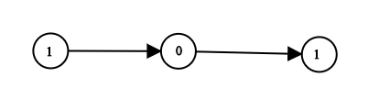

**Input:** head = [1,0,1]

**Output:** 5

**Explanation:** (101) in base 2 = (5) in base 10

**Example 2:**

**Input:** head = [0]

**Output:** 0

**Example 3:**

**Input:** head = [1]

**Output:** 1

**Example 4:**

**Input:** head = [1,0,0,1,0,0,1,1,1,0,0,0,0,0,0]

**Output:** 18880

**Example 5:**

**Input:** head = [0,0]

**Output:** 0

**Constraints:**

* The Linked List is not empty.
* Number of nodes will not exceed 30.
* Each node's value is either 0 or 1.